# Artefact

## FDD

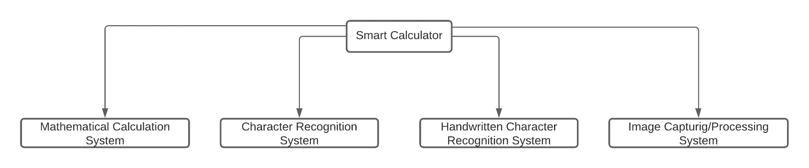

## SRS Legend

Sub Systems:

MCS : Mathematical Calculation System

CRS : Character Recognition System

HCS : Handwritten Character Recognition System

IPS : Image Processing System

MCS - F - 1.0

Types of Requirements:

F : Functional Requirements

NF : Non-Functional Requirements

UR : Usability Requirements

Numbering

**Legend**

## SRS Table

|  |  |
| --- | --- |
| **Requirement Code** | **Requirement Description** |
| MCSF **1.0** | The system should use the built in ALU to perform arithmetic calculations. |
| MCSNF 1.1 | The system should provide the result in less than 1.5 seconds. |
| MCSNF 1.2 | The system should follow BODMAS rule for calculations. |
| MCSUR 1.1 | The system should have “All Clear” button to reset the entry. |
| MCSUR 1.2 | The system should have “Clear Entry” button to erase the latest entry. |
| MCSUR 1.3 | The system should display result in bigger font than the input. |
|  |  |
| MCSF **2.0** | The system should be able to perform scientific calculations. |
| MCSNF 2.1 | The system should be able to point out the error if any occurs. |
| MCSNF 2.2 | The scientific notations should be placed separately. |
|  |  |
| MCSF **3.0** | The system should keep records of the calculations history. |
| MCSNF 3.1 | The system should display maximum five history records. |
| MCSNF 3.2 | The system should have clear history option. |
| MCSUR 3.1 | The system should have black background with white text color. |
|  |  |
| CRSF **1.0** | The system should recognize numbers as well as mathematical notations. |
| CRSUR 1.1 | The notations should be clear and familiar to the users. |
| CRSF **2.0** | The system should recognize characters with noises as well. |
| CRSNF 2.1 | The system should recognize the characters in less than 2 seconds. |
|  |  |
| HCSF **1.0** | The system should recognize hand written characters. |
| HCSNF 1.1 | The system must have handwritten accuracy over 80%. |
| HCSUR 1.1 | The system should ask for confirmation after recognizing characters. |
|  |  |
| IPSF **1.0** | The system should be able to capture image to perform calculations. |
| IPSNF 1.1 | The system should use mobile camera to capture the image. |
| IPSNF 1.2 | The system should capture the in 720*720 resolution. |
| IPSNF 1.3 | After capturing the image there should be crop option. |
| IPSNF 1.4 | There should be save option for image. |
| IPSUR 1.1 | There should be camera icon to switch between standard and scanning calculator. |
|  |  |
| IPSF **2.0** | The system should be able to perform calculations on images from gallery. |
| IPSNF 2.1 | While importing, the images should be shown from latest to old. |
| IPSNF 2.2 | While importing only one image should be selectable. |
| IPSUR 2.1 | The selected image should be faded. |

**\*NOTE:** The SRS will increase along with the development.